**Van Helsing Season 5: Release Date and other details!** 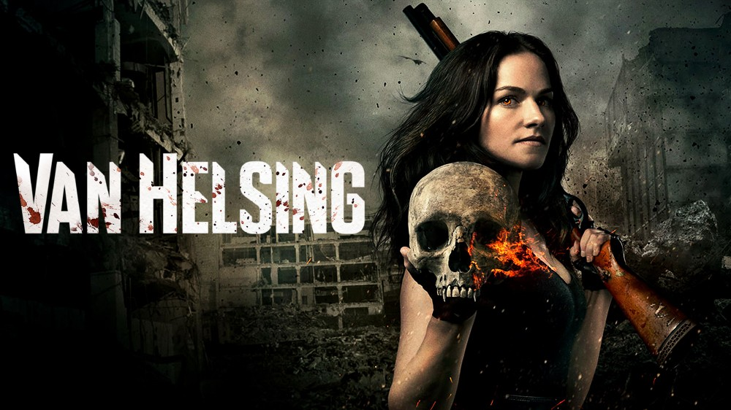

**Van Helsing**, an American- Canadian horror drama television series grounded on the novel series **Helsing** by **Zenescope Entertainment**. This action fantasy is created by Neil Labute, directed by David Winning, and composed by Rich Walters.

**Van Helsing Season 5: Release Date**

Helsing by Zenescope Entertainment was announced to be adapted for the production of **Van Helsing Season** 1 in November 2015. Its filming began in January 2016 and it gets released on July 31, 2016. It consisted of 13 episodes. Then on October 14, 2016, the series was renewed for **13-episode** **season** 2, which aired on October 5, 2017. On December 19, 2017, the series was renewed for 13-episode season 3, which was **released** on October 5, 2018. On December 18, 2018, the **series** was renewed for 13-episode **season** 4, despite the backout of the showrunner of the previous three seasons. On December 17, 2019, the series was renewed for a **fifth** and **final season** of the show. As per the trends, **Van Helsing Season 5** must have been on the viewers' screen by 2020s' October. But owing to covid-19 restrictions the production and filming of the final **season** got delayed and its release has been pushed further to 2021. As per showrunner Jonathan's statement, the production and filming for **season 5** have already been completed, So, one can expect the announcement of the **season 5** premiere anytime. Let's see when do they release it on the viewers' screen.

**Van Helsing Season 5: Probable Cast and Plot**

Protagonists of the show are likely to repeat their roles in **Van Helsing Season 5**. Additionally, there may be few more characters but nothing has been unveiled by the creators to prevent the show's suspense to be sabotaged. So, let's recap a few lead characters who appeared in the previous seasons and are likely to appear in **season 5**.

**Vanessa Van Helsing** played by Kelly Overton- She's a descendent of Abraham **Van Helsing**, whose unique blood has the power to turn vampires back into humans. So, she's the only ray of hope for humanity. Because of her unique capabilities, she becomes a prime target for the vampires. She's protected from the vampires by a Marine assigned to save her life and the doctor who saved her so that she can save humanity from the blood-sucking creatures. Later in the show, she meets her long-lost sister **Scarlett**, who's well tutored to hunt down vampires since birth. Both of them collectively progress to end the bloodsuckers.

**Axel** Miller played by Jonathan Scarfe- She's the one who remains isolated for many years in the show. She's ordered to protect Vanessa from the vampires and she's faithful and highly devoted towards her duty.

Samuel Sam played by Christopher Heyerdahl- He's a sociopath and serial killer before he turned into a ruthless vampire, who likes to cut off the right index finger of his victim and collect them to use them into a necklace. When Mohamad comes to know about his ruthless secrets then he reveals them to Vanessa and she cuts his tendons and leaves him to die but he was turned into a vampire by a feral vampire and thus he keeps on searching for Vanessa to take his vengeance. Later in the show, he's transformed into the Fourth Elder Vampire.

John played by David Cubitt- He's mistakenly understood to be the serial killer by Vanessa who kills him. Later on, it's unveiled that Sam is the real serial killer.

Flesh Played by Vincent Gale- He was a human named Phil Fleishman who was later turned into a vampire by Julius during the Rising. He was sent to bite Vanessa because of which he got cured and got back his humanity. But he wasn't able to live peacefully, because when he became a vampire, he killed his children in front of his wife and he left alive with their bodies which haunt him forever.

Sarah "Doc" Carol is played by Rukiya Bernard- A vampire who was cured by Vanessa. 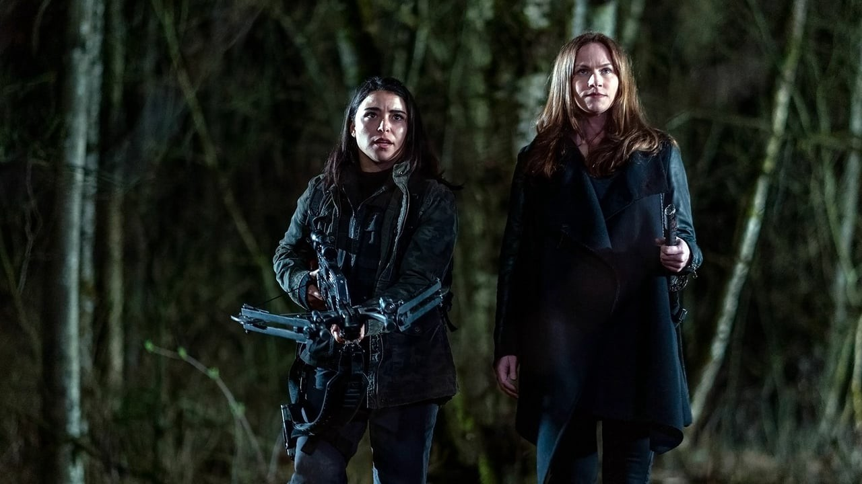

Mohamad played by Trezzo Mahoro- He's a merrier person who tried in **season** 1 to get **Vanessa** trapped in Dimitri to free his sister. He's a close friend of Sam, the serial killer. But later in the show when he knows about the secrets of Sam, he gets him killed by Vanessa, but Sam gets turned into a vampire by a feral vampire and thus he's turned by Sam who stabs him later in the show.

Rebecca played by Laura Mennell- She's a very high-ranking ancient vampire, who has very low regard for human life. She works to overthrow Dmitri by taking help from Taka. She's the one who turned **Dylan**, Vanessa's daughter into a vampire. Her face is burnt in the sun by Vanessa in a fight and later on, she's killed by Antanasia, Dmitri's sister.

Dmitri played by Paul Johansson- An ancient vampire, who's the leader of the vampires and he's obsessed with finding Vanessa whom capabilities he believes can be used by the vampires to move during the sunlight without getting burnt. Later in the show, he gets slaughtered by the First Elder, on Scarlett's order.

Julius played by Aleks Paunovic- A vampire turned by Dmitri, who is cured by Vanessa and thus he teams up with her in the fight against vampires.

And thus, we can conclude that **Van Helsing Season 5** is likely to revolve around Vanessa and Scarlett tracking and hunting down the vampires. It'll show humans turning into vampires and vampires cured into humans by **Vanessa** unveiling more mysteries and adventure in the storyline.

**Van Helsing Season 5: Trailer**

The **Season 5 trailer** has not been released yet by the creators so till that time you can enjoy watching the **trailer** of **Van Helsing Season** 4😊

https://www.youtube.com/watch?v=uEibXUfUSGo